**My Blog Software requirements**

**Goals**

1. Create a blog to be able to share and stories and knowledge with others

**User Stories**

As a <user>, I want <goal> so that <some reason>

Task: Complete 3rd User Story for being able to add a new post

1. As a viewer, I want to see the list of blog posts so that I can see the blog and topics for me to choose
2. As a viewer, I want to view an individual blog post so that I can read all of its content
3. As an admin, I want to add a new blog post so that I can easily add content to my blog

**User Flow**

Task: Complete the 3rd User Flow

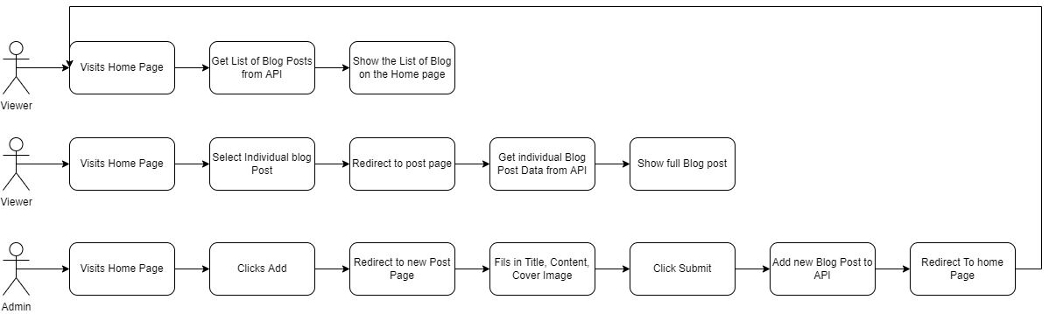

**Buisiness Requirements**

* Pages
  + Home Page
  + Individual Blog Post Page
  + New post Page
* Home Page
  + Display user profile image
  + Display list of blogs with Title, Date, Content
  + Limit the blog text to a certain height
* Individual Blog Post Page
  + Show the cover image, title, content, added date
  + Allow the user to go back to home page
* New post Page
  + Allow a user to fill in title, content, and select the cover image
  + Store the added date

**Technical Requirement**

* Front End using javaScript
* Back End using Nodejs
  + Rest API
* Database
  + JSON
* API endpoints
  + Get List of Blog Posts
    - “api/posts”
  + Get Individual Blog
    - “api/posts/:post_id”
  + Post blog Post
    - “api/posts”